GOING HOME
Github links:
https://aswathykk.github.io/P5_js/weekend%20assignmen_new/ https://github.com/Aswathykk/P5_js/blob/main/weekend%20assignmen_new/sketch.js

This game poem is about a man who is trapped in the endless cycle of corporate life. Over time, he loses touch with himself, his emotions fade, his expressions vanish, and he becomes just another face in the crowd. One day, he boards a train, puts on his earphones, and leaves the city behind. Along the journey, he begins to rediscover his emotions, identity, and the sense of being alive that he had lost. Ultimately, the journey leads him back home not just a physical place, but a state of peace in which he reconnects with his true self.
How the idea came:
At first, I was stuck. I had too many ideas and wasn’t sure which one to follow. The very first idea that came to me was about a child trapped in a nightmare world. The story began with the child sleeping peacefully, and his face keeps changing as the nightmare takes over then slowly falling into his nightmares. In the darkness, he hears his mother’s voice a soft, familiar sound that guides him back. Through her voice, he finds the way out of the nightmare and returns to safety.
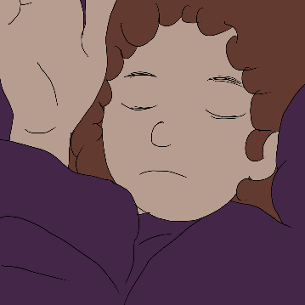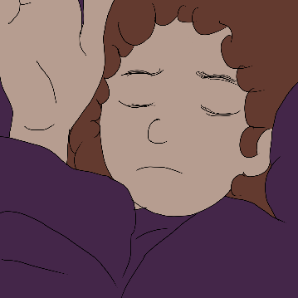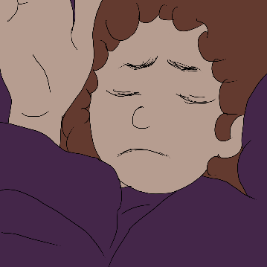
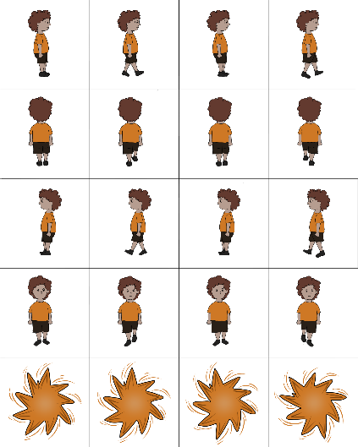

But I wasn’t able to concentrate or move forward with my idea. That week, I was planning to go home, and I was feeling very homesick. At that time while scrolling through Instagram, I came across a Malayalam song, Chaanjadi Aadi Urangu Nee. There was a verse in it about going home, and it made me feel even more homesick. My mind went blank, and I couldn’t think of any new ideas. Then I thought, maybe I could create something about going home something I would feel emotionally connected to, rather than just another assignment. That’s when I decided my theme would be going home.
Then I thought that if I simply made it about going home and finding happiness, it would feel too literal. Home can be many things ..a place, a person, or simply a state of being where we feel like ourselves. I felt that, in today’s world, the best way to express this idea was through a corporate character. I’ve seen many videos of people talking about being stuck in the rat race.. always busy, chasing deadlines, working late nights, and losing touch with themselves. So, I decided to make a corporate person the main character of my game poem.
In the first scene, a sad background music starts playing. The character is working late when he receives a Teams call something most corporate employees dread. He declines the call and decides to head home. As he walks through the city, the sound of high-pitched vehicle horns fills the background. I added these sounds to make the player feel more emotionally connected to his tired, chaotic world.
In the next scene, he is on a train, with changing images of the city in the background. All these scenes are in black and white, and his face is left blank to show his emotionless, colourless life one that feels empty and directionless. Then he puts on his headphones, and the song Home begins to play. I was quite confused while choosing the song, but I finally selected this one because its meaning fits perfectly. The song portrays home not just as a physical place, but as a state of emotional connection.. it could be a loved one, a comforting space, or even something simple like a warm pumpkin pie.
As he listens, the background slowly changes into greenery. His facial features begin to return, his emotions and colours come back to life. In the final scene, the greenery completely fills the screen, and he is shown lying in a field with his pet, a moment of peace where he finally finds his home.
Design and issues faced:
- Initially, I didn’t have the option for declining the Teams call, but I added it later to make the player more involved and interactive.
- For the headphone part, I first thought of changing frames, but then decided to use a pop-up instead, as it felt more engaging.
- In the beginning, I made some random drawings just for testing. Once the concept became clear, I created the final set of drawings properly.
- I wasn’t sure what to name the project at first. Since the theme was going home, I decided to use that as the title. In the final scene, where he finds peace, I added the text “HOME.”
- I wanted to keep the frame centered on the screen. I tried several methods, but it kept getting clipped or distorted. Eventually, I wrote a function to resize and center the image correctly. The calculation didn’t work at first, so I looked up some references online to fix it.
- To stay organized, I created separate functions and variables for each scene, so I wouldn’t get confused during coding.
- When I tried changing the city background to the green one, it first appeared as a glitch. But since it actually matched the tone of that transition, I decided to keep it as a part of the scene and added the new green scene with a delay.
- At one point, I mistakenly named my folder assests instead of assets. Because of that, nothing was loading properly during preload, and I spent around 45 minutes figuring out what went wrong.
Future:
- I would like to add more scenes in the story to make it longer and more interesting.
- I want to add more ways for the player to interact with the game.

